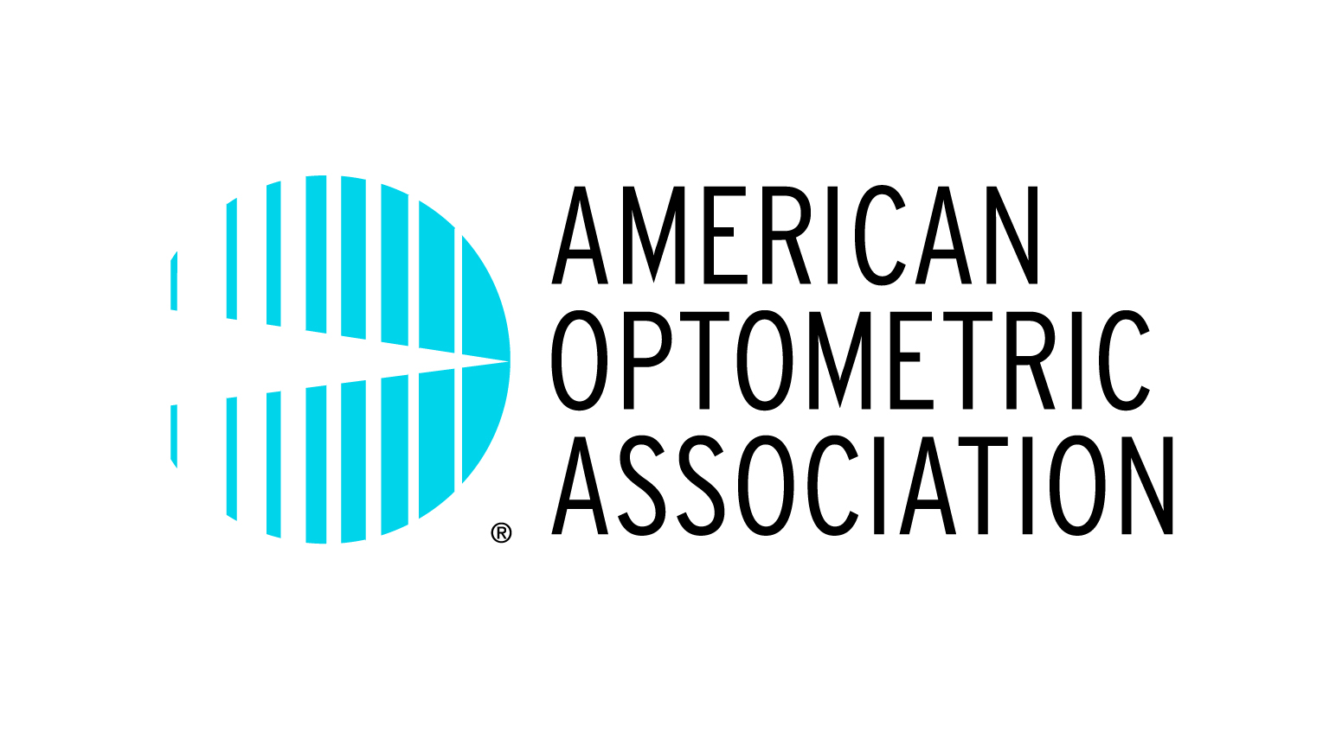 | AMERICAN OPTOMETRIC ASSOCIATION  2015 CONGRESSIONAL ADVOCACY CONFERENCE  April 12-14, 2015  JW Marriott Hotel  1331 Pennsylvania Avenue, N.W. ● Washington, D.C., 20004 ● (800) 393-2503

Registration Forms must be received faxed no later than Monday, March 9, 2015

Name __________________________________________________________________ |  | Badge _________________________
Address ________________________________________________________________
City ____________________________________ | State _________________________ | Zip ____________________________
Office phone ____________________________ | Fax __________________________ | Email __________________________
Emergency contact _______________________ | Relationship ___________________ | Phone _________________________

In accordance with the Americans With Disabilities Act, check here if you require special accommodations to fully
participate. Please attach a written description of your needs and the AOA will contact you.

Please check your affiliation noting the applicable registration fee. All functions are included.
AOA Board |  | State Designated Attendee (including EDs) | $0
AOA Volunteer |  | Deans/Presidents | $299
AOA Student Liaison |  | Other | $299
AOA Staff
 |  | Attendee total fee | $ __________
Please select which functions you will attend.

Sunday, April 12 | Welcome Reception
Monday, April 13 | CE Course (ODs only) | Lunch
Tuesday, April 14 | Breakfast of Champions

Please check any special dietary needs you require:
Diabetic Meals | Kosher Meals | Vegetarian Meals | Food Allergy _______________
SPOUSE/GUEST NAME______________________________________________ BADGE NAME ______________________

Optional food function tickets are available for your spouse/guest at an additional charge. Tickets will be required for all events. Please check the functions your spouse/guest will be attending and remit payment with registration.
Reception –- Sunday, 4/12 ($45) Lunch – Monday, 4/13 ($60) Breakfast of Champions – Tuesday, 4/14 ($40)
Spouse/guest total fee $ __________
HOTEL RESERVATIONS:
Congressional Advocacy Conference attendees are responsible for making their own hotel reservations. The AOA group rate is $329 + tax for single or double occupancy. To receive the group rate call (800) 393-2503 and ask for the AOA 2015 Conference rate or make your reservation online at https://resweb.passkey.com/go/wasjw2015aoa. The deadline for hotel reservations is March 9, 2015. After this date the group rate cannot be guaranteed

AOA reimbursement policy requires your arrival and departure dates: Arrival __________ Departure __________
PAYMENT INFORMATION:
I authorize the AOA to charge the credit card below the total of the attendee and spouse/guest fee. Total fee = $ __________

Please circle one: AX MC VISA Check (send along with this registration form to the address below)
_________________________________________ _________ _____________ ________________________________
(credit card number) (exp. date) (security code) (card holder’s signature)

If paying by check:  Mail this form along with your check made payable to the American Optometric Association for the appropriate amount, to:  American Optometric Association  ATTN: Jill Parker  243 N. Lindbergh, Floor 1  St. Louis, MO 63141 |  | If paying by credit card:  Fax this form to (703) 739-9497  ATTN: Tess Milliorn.  Questions regarding registration?  Contact Tess Milliorn at (800) 365-2219, Ext. 1345  or TMilliorn@aoa.org.

